|  |
| --- |
|  |



**16 November 2012** **The Weekly Bulletin of Rotary Club of Kathmandu Mid-Town** **Bc-16.11/012-13**

District : 3292 Web:www.rotarymidtown.org.np Club Id : 26776

**NOVEMBER IS THE ROTARY FOUNDATION MONTH**

In anticipation of The Rotary Foundation’s 100-year anniversary in 2017, the Trustees set out to develop a plan to move the Foundation toward its second century of service. The plan was designed to reflect the desires and interests of Rotarians worldwide to give the Foundation a more sustainable and visible impact in the world.

 . 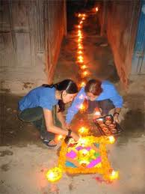

.

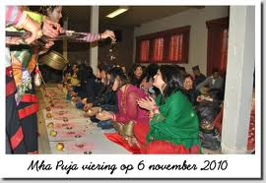

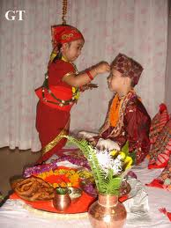

**Tihar Celebration**

Tihar, the festival of lights, an occasion to be with

family and share a special bond by observing all the

rituals, is here bringing along lots of hope, amongst,

particularly young generation. This is also a time

for the lights to eliminate all the evils in society and

spread the message of good will.

Friday, 9 November:

Guest Speaker, HE German Ambassador Frank Meyke who had been to

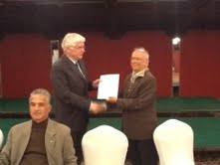

9 countries, before coming to Nepal, in his diplomatic missions, the first

assignment being in German Embassy in Nairobi/Kenya in 1979, provided

an interesting account of his professional experience when he was German

Consul General in Novosibirsk/Russia. He also narrated some of

development issues and challenges dealt with while he was German

Ambassador in Dacca/Bangladesh.

President Devendra providing a letter of

appreciation to the Guest Speaker

# Weekly Meetings and Programs :

|  |  |  |
| --- | --- | --- |
| Date | Program/Speaker | Program/Topics of Presentation |
| 16 Nov 2012 | No meeting | Regular meeting of the day combined with the Charter Night |
| 19 Nov 2012 | Charter Night | Charter Night celebration |

**Charter Night on 19 Nov, Monday:**

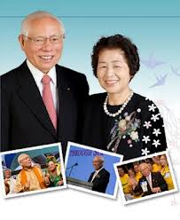

***Do not miss !!!***

**Rotary Club of Kathmandu Mid-Town is making a history - RI**

**President Sakuji Tanaka, on District visit trip scheduled for**

**19 to 21 November, will be the Chief Guest on Club’s Charter**

**Night Celebration. RI First Lady Kyoko will also grace the**

**Celebration. Do not miss this unique opportunity and honour**

**the Club given with, thanks to the effort of none other than**

**District Governor Yogendra.**

RI President Sakuji and First Lady Kyoko

***Induction of 3 new members:***

**During the Charter Night, three international personalities are scheduled to be inducted into the Club membership. They are:**

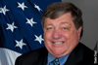 **Peter W. Bodde, US Ambassador to Nepal**

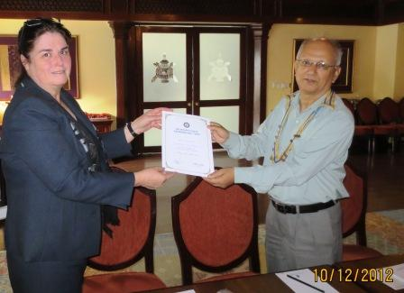 **Catherine Sue Jenson, CEO of Sheer Memorial Hospital, Banepa**

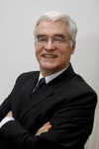 **Frank Meyke, German Ambassador to Nepal**

**RI District 3292 Programs:**

Monday  19 November  17:00 - 18:30 hrs    **RI President Meets Major Donors**

Tuesday  20 November   13:15 - 15:30 hrs   **Gopal-Kamala Rajbhandary Rotary Award for ocational Excellence**

at Rashtrapati Bhawan

“ “ 16:00 - 21:00 hrs   **The Rotary Foundation Seminar** at Hotel Yak & Yeti, Durbar Marg

Wednesday  21 Nov   08:30 - 14:00 hrs   **The Rotary Foundation Stewardship Seminar**

at Shalimar Apartment Hotel, Jawalakhel

**Globetrotter raises Rotary flag over South Pole:**

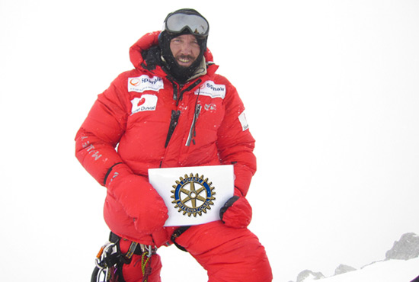

Reaching the South Pole has not been Albert Bosch's only adventure. Son of a past

district governor, he has climbed the highest peaks on every continent.

**A**lbert Bosch started his trek to the South Pole on 30 October 2011, hauling food,

water, shelter, and a Rotary flag in honor of his late father, Josep Bosch.

“You don’t see a single person, animal, or change of scenery,” he says. “There is no

difference between the day before and the day after. Every day is exactly the same.”

On 4 January, after 52 days on foot, pulling everything he needed on his nearly 300-pound sled, Bosch made it to the pole. Reaching the South Pole may be his latest accomplishment, but it’s far from his only adventure. Bosch has climbed the highest peaks on every continent, ending with Mount Everest in May 2010, where he also brought a Rotary flag.

“I have a special feeling for Rotary due to its importance in my father’s life,” he says. The elder Bosch founded the Rotary Club of Ripollés, Spain, then joined the Rotary Club of Barcelona-Diagonal; he served as district governor in 1995-96.

Bosch’s next challenge will be trekking from Canada to the North Pole in 2014. “Of course I will be carrying a Rotary flag,” he says. “It is already in my luggage.”

*Source:*Susie Ma/Rotary International News

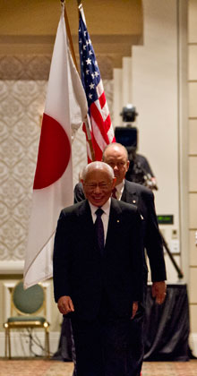

*Through our Foundation, we have the power to live the words of our Foundation’s*

*motto: Doing Good in the World. Through it, we can do so much more good than we*

*could ever do alone. And it matters so much – to people just like us.*

**RI President Sakuji Tanaka**

On Lighter Side :

Click here ⇩



**A THOUGHT FOR THE DAY:**

**There is a wonderful mythical law of nature that three things**

**that we crave for most in life - happiness, freedom, and peace of mind,**

**are always attained by giving them to someone else -**

**Let us all share our happiness !!!!**

**Great Quote:**

***Imagination is more important than  knowledge !***

**A puzzle:**

*What number should follow in the series: 3, 4, 10, 33, 136, …*

NB: If you have any information/photo that may be of interest to Rotarians send them to

BC Editor: RR Shrestha email: rryesrr@gmail.com

## 16 Nov 2012 The Weekly Bulletin of Rotary Club of Kathmandu Mid-Town bc-16.11/012-13